PURPOSED METHODS TO ELIMINATE OVERLOAD POWER SYSTEM PROBLEM

Kadri Buruncuk Daoud AL-hamad
e-mail buruncuk@neu.edu.tr e-mail: daouden@yahoo.com

Near East University, Faculty of Engineering, Department of Electrical & Electronics Engineering, Nicosia, Turkish Republic of Northern Cyprus

Key words: Overload Analysis, Overload causes, Overload Eliminating

ABSTRACT
This study attempts in solving one of the long term instability voltage phenomena which is overload power system, however, overload problem is a critical problem in power system operation, simple and efficient methods for eliminating different branches of overload problem in power systems are presented.
The methods are depending on the type of the overload that the system is suffered.Simulations have been carried out for medium voltage proposed case study (overload case) contains 15 buses using Matlab software program in order to show the effectiveness of the proposed methods.

I. INTRODUCTION
For every country, power system is the heart of industrial growth and welfare as well as socio-economic development. In developing countries, there is always shortage of generation, losses of transmission lines, heating in transformers as compared to the rapidly increasing load demand. However, no power condition in any country will bring every thing to a halt. Heavy loading of a system or tripping of any one of its lines in the grid causes the reduction of the receiving end voltage. If this voltage is decreased beyond the limit, overload problem and voltage instability may be observed.
This study is motivated to contribute in solving one of the long term instability voltage phenomena which is overload power systems. In other world the system has limitation of generation and transmission line or limitation from transformers, knowing that the temporary solutions are not useful to elevate the overload problem. Any power system may face either one of these limitations or all of them together.
The study will introduce real life application solutions that depend on the type of overload problem such as converting from single to bundle or parallel conductor in transmission line, adding new parallel generator to the main generators, adding reserve distribution generators to the system, and adding parallel transformers to the old transformer. The main objective of these proposed methods is to enhance the voltages of the whole power system.
Several overload alleviation methods have been proposed in the literature. In [1], [2] and [3] generation rescheduling and load shedding methods based on generation shift factors are proposed to elevate line overload. In [4] Non linear programming has also been used for finding coordinated control actions to eliminate overloads.

II. EXPERIMENTAL
Proposed study case, is a power system circuit in the medium voltage level, 66KV, with15 bus-bar. The system consists of two main steam turbine generators, two delta-delta step up transformers, thirteen transmission lines with maximum current capacity of 270A, and nine loads with their delta-wye step down transformers shown in figure1.1. Matlab software program has been used in order to simulate these cases study.

III. OVERLOAD ANALYSIS
The P-V curve describes graphically the impact of an increase in real power (MW) due to consumer demand and system voltages shown in figure 1.2. As the demand of reactive power (MVAR) is increased due to higher power transfer on lines driven by consumer demand, system voltages will decrease. The end of the curve, frequently called the nose, represents the maximum load that can be served. The difference between the operating load point and the maximum load point is the real power
(MW) margin and is required to maintain reliability [5].

IV. OVERLOAD CAUSES
Voltage stability is the ability of a power system to maintain steady acceptable voltages at all buses in the system under normal operating conditions and after being subject to disturbance. A system enters a state of voltage instability (overload) when the disturbance, increase in load demand, or change in system condition causes a progressive and uncontrollable drop in voltage. The main factor causing instability is the inability of the power system to meet demand for reactive power [6]. The problem of an overload occurs from the followings:
- Shortage of Reactive Power
- Limitation of Generated Power
- Limitation of Transmission Lines
- Limitation of Transformers
- Supply Interruptions
- Under-voltage
- Harmonics
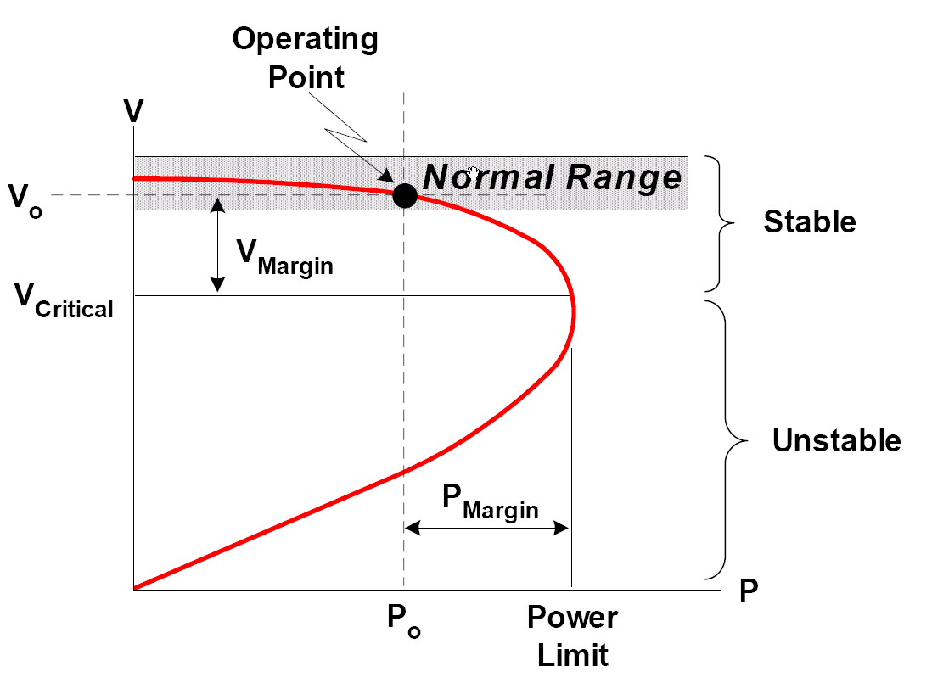

Figure 1.2 Real Power-Voltage (PV) Curve.

in two types of overload causes are considered ,first one is limitations of generations and transmission lines . However, The two main generators will be heavy loaded, have limitation of active and reactive power because of increasing the power loads and become overloaded ,second one is limitation of transfomers In order to show the limitations of transformers without considering generation and transmission line limitation, some changes of the power loads in proposed circuit. In the new proposed circuits only three loads will be increased to have an overload circuit with transformer limitation which are the loads (1, 4, 5) as shown in table 1.1. The changes of the power load will be more than the power transformer tolerance which is above 120% [7].

Table 1.1 Compare Between Power Load and Power Transformer Values

Loads Number | Overload Circuit
Loads Number | Transformer  MVA | Load  MVA
1 (L1) | 10 | 11.2
4 (L4) | 15 | 20.1
5 (L5) | 15 | 30

V. OVERLOAD ELIMINATING
The electricity industry has always been interested in expanding investment in the all power system sectors of the industry. As load demand increases and generation expands to meet the need, transmission expansion becomes important in order to increase social welfare by reducing total system operating cost, and to make the system more reliable. Some methods to eliminate overload will be applied to the overload circuit which are summarized in adding parallel generator to the main generator, adding distribution generator near the heavy loaded, adding parallel transmission line, adding bundle transmission line, putting parallel distribution transformer to the old transformer.

A) Convert from Single Conductor to Bundle Conductors (Solution 1)
In this circuit, the first solution will be applied which is converting the most heavy loaded transmission line to bundle conductor (two wires) especially transmission line number 1, 2, 3, 4, 11, 12 and 13.Table1.2.shows the differences between the RLC values of single and bundle conductor which are calculated by Matlab program for the 270A transmission line.

Table 1.2 The RLC values of the transmission lines in per unit length

Transmission Line | R(ohm/km) | L(mH/km) | C(nF/km)
Single Conductor | 0.436 | 1.5889 | 7.022
Bundle Conductor | 0.21805 | 1.2027 | 9.2969

B) Convert from Single Conductor to Parallel Conductors (Solution 2)
In this circuit, the second solution will be applied which is converting the most heavy loaded transmission line same as bundle conductor into parallel transmission line.

C) Parallel Generator with Parallel Transmission Line (Solution 3)
In this circuit, the third solution will be applied which is adding parallel steam turbine generators to the main generators (G1, G2) with same specification of transformers connected with timer circuit breakers , in this solution at the begging we purposed that it will have only two parallel generators working synchronically. But this solution was not enough to eliminate the overload problem due to increasing the supplyingof active and reactive power and the capacity of the transmission line cannot carry the new changes in the generators so some of these transmission lines will be changed into parallel transmission line especially 2, 4, 11, 12 and 13.Table 1.3 shows the rating of the each steam turbine generators.

Table 1.3 Generator Values

Generator Number | Power Generated | Generator Rating
G1(Main) | 60MVA | 7500
G2(Main) | 60MVA | 7500
G3 (parallel) | 30MVA | 7500
G4 (parallel) | 30MVA | 7500

D) Adding Distribution Generator (Solution 4)
In this circuit, the forth solution will be applied which is adding three distribution diesel generators to the overload circuit connected with timer circuit breakers as piecemeal (one by one with different time) ,the places of the distribution generators are chosen beside the most loaded part in the circuit. Table 1.4 shows the rating of two main steam turbine and three diesel generators, the power transformers of diesel generator have 20MVA and 4.2KV_70KVrating.

Table 1.4 Generator Values
Generator Number | Power Generated | Generator Rating
G1(Main) | 60MVA | 7500
G2(Main) | 60MVA | 7500
DG1(Distribution ) | 20MVA | 4200
DG2(Distribution ) | 20MVA | 4200
DG3(Distribution ) | 10MVA | 4200

E) Adding parallel Transformer (Solution 5)

In this circuit, the fifth solution will be applied which is adding parallel transformer to the three loaded loads which are (1, 4, 5) as explain above, where these transformers have the same specification working synchronically. Table 1.4 shows the comparing between the sum of power transformer values after changing and power loads.

Table 1.4 Represent the changes of the power Transformer Values

Loads Number | Overload Circuit
Loads Number | Transformer  MVA | Load  MVA
1 | 20 | 11.2
4 | 30 | 20.1
5 | 30 | 30

IV. RESULTS AND DISCUSSION
The work was carried out on a Pentium 4, 3.0 GHz CPU with 512 Mb of RAM computer using windows XP. The results is taken as voltage and current in the distribution systems (in the load parts).and the five solutions are summarized in the tables as:
- Solution 1 = Convert from single conductor to bundle conductors
- Solution 2 = Convert from single conductor to parallel conductors
- Solution 3 = Parallel generator with parallel transmission line and
- Solution 4 = Adding distribution generator.
A) Transmission Line Changing Results
Table 4.19 introduces RMS one phase voltages a of every load for overload case and solutions 1 and 2. In the overload case loads 1, 4, 6, 8 and 9 are overloaded (e.m. the voltages are less than 0.95 p.u.). After changing to bundle conductor all of these load voltages are increased 0.967 p.u. and after switching parallel T.L. they are increased to more than 0.971 p.u. From these results it is seen that changing bundle conductors or adding parallel transmission lines can solve the problem of transmission line limitation and hence can clean the overload and raise the load voltages. The reason for this is because the more transferred power and less voltage drop in T.L.

Table 4.19: Per Unit Voltage Values in Distribution Side
Loads Number | Overload | Solution 1 | Solution 2
1 (L1) | 0.9389 | 0.998 | 1.013
2 (L2) | 0.999 | 1.038 | 1.039
3 (L3) | 0.9725 | 1.034 | 1.040
4 (L4) | 0.8995 | 0.974 | 0.973
5 (L5) | 1.0521 | 1.065 | 1.067
6 (L6) | 0.9137 | 1.004 | 0.970
7 (L7) | 0.9893 | 1.027 | 1.043
8 (L8) | 0.8987 | 0.979 | 0.982
9 (L9) | 0.8655 | 0.967 | 0.972

B) Generators Changing Results
Table 4.21 introduces the transmission line currents for the overload case and after using solution 3 (switching on reserve generators) and using solution 4. It is seen from column 3 in table 4.21 (solution 3 T.L. currents) that some of them are overloaded or raised to large value which affect the value of increasing generating power. After study it is obvious that these transmission lines should be changed to bundle or adding parallel T.L. In our case adding T.L. in parallel is used in T.L. number 2, 4, 11, 12 and 13. Also it is seen from column 4 in the same table (solution 4 currents) that most T.L. passes less currents especially in the very loaded T.L. because the power is generated and induced near the high overloads. Solution 4 (distribution generators) can solve the problem in a less cost but in worse environmental conditions (because the generators are near the consumers areas).

Transmission Line  Number | Overload Circuit | Solution 3
1 (TL1) | 142 | 143.79
2 (TL2) | 265 | 279.60
3 (TL3) | 167 | 176.65
4 (TL4) | 210 | 239.29
5 (TL5) | 84.3 | 103.30
6 (TL6) | 74 | 80.167
7 (TL7) | 5 | 13.959
8 (TL8) | 147 | 107.43
9 (TL9) | 150 | 106.01
10 (TL10) | 7.74 | 26.697
11 (TL11) | 267 | 324.40
12 (TL12) | 206 | 214.55
13 (TL13) | 109 | 121.29

Table 4.21: Per Unit Voltage Values in Distribution Side

Loads Number | Overload | Solution 3 | Solution 4
1 (L1) | 0.9389 | 0.9528 | 0.966
2 (L2) | 0.999 | 1.062 | 1.018
3 (L3) | 0.9725 | 1.048 | 1.009
4 (L4) | 0.8995 | 0.958 | 1.000
5 (L5) | 1.0521 | 1.061 | 1.075
6 (L6) | 0.9137 | 0.959 | 0.985
7 (L7) | 0.9893 | 1.029 | 0.978
8 (L8) | 0.8987 | 0.97 | 0.996
9 (L9) | 0.8655 | 0.959 | 0.959

C) Transformer Changing Results
Increasing the consumed voltages of the system, make some adjustments to the settings of the transformer, or possibly some transformer replacements, in order to produce the new operating voltage. Tables 4.26 shows the changing in per unit values of voltage in distribution side especially the 1,4,5 loads the overloads are raised to more than 0.9632 p.u. thus cleaning overload after using parallel distribution transformers. It is concluded that when the only cause of overload is limitation of distribution transformers, it can be solved by adding parallel distribution transformers to the heavy loaded transformers.

Table 4.26: Per Unit Voltage Values in Distribution Side
Loads Number | Overload Circuit | Parallel Transformer Solution 5
1 (L1) | 0.9317 | 0.9632
2 (L2) | 1.0474 | 1.0437
3 (L3) | 1.0181 | 1.0133
4 (L4) | 0.9445 | 0.9744
5 (L5) | 0.946 | 0.9995
6 (L6) | 0.9865 | 0.9793
7 (L7) | 0.9899 | 0.9885
8 (L8) | 0.9931 | 0.9888
9 (L9) | 0.9852 | 0.981

V. CONCLUSION
This study discusses a major power system disturbance which is overloading problem. Overloading of limitation in generator, overloading distribution transmission lines, overloading of distribution transformers and distribution power losses are verified and it is observed that the system suffers the consequences of overloading effects in the distribution network. Here, the aim is to help the distribution network to be able to operate within the rated values hence to be able to handle power demand of the area with the load growth. By applying prior mentioned solutions to the proposed system, overload problem well handled and the simulation results were satisfied. However, latency problem, especially when obtaining the graphical results, was a negative point

REFERENCES
- Shandilya, A. Gupta, H. and Sharma, J. (1993) “Method for generation rescheduling and load shedding to alleviateline overloads using local optimization”. IEE Proceedings: Generation, Transmission and Distribution, Volume: 140, Issue: 5, p.p 337-342
- El-Ela, A.A.A. Tweig, N.T.. (2004) “Line switching reconfiguration corrective action for overloads in power systems”. Universities Power Engineering 39th International Conference, Volume: 3, p.p:992 – 998.
- Mohamed, A., and Jasmon, G.B. (1988) “Realistic Power System Security Algorithm” Department of Electrical Engineering, Volume: 135, p.p:98-106 ,Kuala Lumpur
- Abrantes, H.D. and Castro, C.A.(2000) “New Branch Overload Elimination Method Using Non Linear Programming”. IEEE Meeting, Power Engineering Society, and Volume: 1, p.p: 231-236.
- Khudai, J. (2006), American Transmission Company, “3M Aluminum Conductor Composite Reinforced Application(ACCR)”, “www.atcllc.com/documents/3MTechnologyandDaneCounty_v2_200600906.doc”
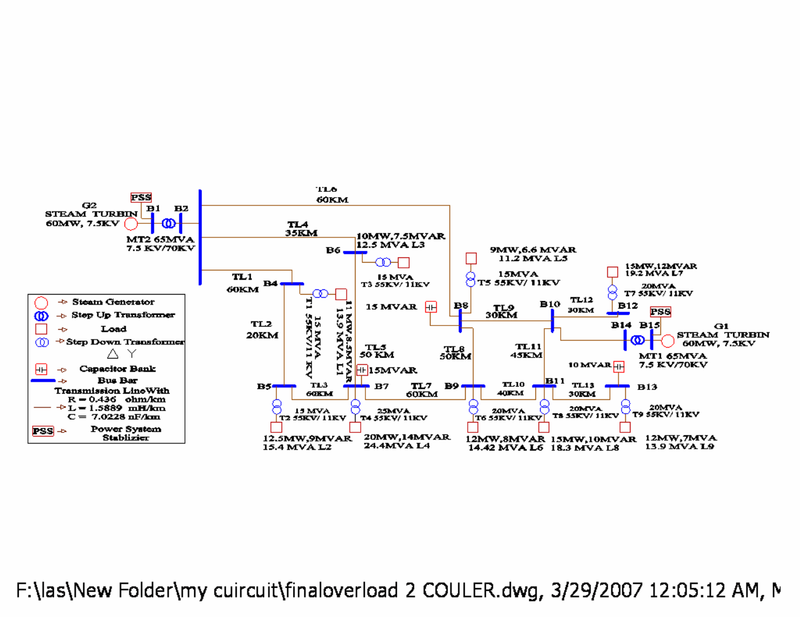
- Begovic, M., Milosevic B., and Novosel ,D.,(2002), “A Novel Method for Voltage Instability Protection” IEEE 35th Annual International Conference on System Sciences, p.p: 802- 811. Hawaii.
- Harlow, J. (2004) “Electric power transformer engineering” CRC Press LLC, Boca Raton

